create database virtualartgallery

use virtualartgallery

--ARTISTS TABLE

create table artists(

artistid int primary key,

name varchar(255) not null,

biography text,

nationality varchar(100))

-- CATEGORIES TABLE

create table categories(

categoryid int primary key,

name varchar(100) not null)

--ARTWORKS TABLE

create table artworks(

artworkid int primary key,

title varchar(255) not null,

artistid int,

categoryid int,

year int,

description text,

imageurl varchar(255),

constraint fk_aid foreign key(artistid) references artists(artistid),

constraint fk_cid foreign key(categoryid) references categories(categoryid))

--EXHIBITIONS TABLE

create table exhibitions(

exhibitionid int primary key,

title varchar(255),

startdate date,

enddate date,

description text)

--EXHIBITIONARTWORKS

create table exhibitionartworks(

exhibitionid int,

artworkid int,

primary key(exhibitionid, artworkid),

constraint fk_eid foreign key(exhibitionid) references exhibitions(exhibitionid),

constraint fk_awid foreign key (artworkid) references artworks(artworkid))

insert into artists (artistid, name, biography, nationality)values

(1, 'Pablo Picasso', 'Renowned Spanish painter and sculptor.', 'Spanish'),

(2, 'Vincent van Gogh', 'Dutch post-impressionist painter.', 'Dutch'),

(3, 'Leonardo da Vinci', 'Italian polymath of the Renaissance.', 'Italian');

insert into categories(categoryid, name) values

(1, 'Painting'),

(2, 'Sculpture'),

(3, 'Photography');

insert into artworks(artworkid, title, artistid, categoryid, year, description, imageURL) values

(1, 'Starry Night', 2, 1, 1889, 'A famous painting by Vincent van Gogh.', 'starry_night.jpg'),

(2, 'Mona Lisa', 3, 1, 1503, 'The iconic portrait by Leonardo da Vinci.', 'mona_lisa.jpg'),

(3, 'Guernica', 1, 1, 1937, 'Pablo Picassos powerful anti-war mural.', 'guernica.jpg');

insert into exhibitions (exhibitionID, title, startDate, enddate, description) values

(1, 'Modern Art Masterpieces', '2023-01-01', '2023-03-01', 'A collection of modern art masterpieces.'),

(2, 'Renaissance Art', '2023-04-01', '2023-06-01', 'A showcase of Renaissance art treasures.');

insert into exhibitionartworks(exhibitionid,artworkid) values

(1, 1),

(1, 2),

(1, 3),

(2, 2);

--1

1.Retrieve the names of all artists along with the number of artworks they have in the gallery, and

list them in descending order of the number of artworks.

select a.name,count(aw.artworkid) as artworks

from artists a

left join artworks aw

on aw.artistid = a.artistid

group by a.name

order by count(aw.artistid) desc

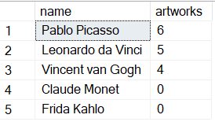

--2

2. List the titles of artworks created by artists from 'Spanish' and 'Dutch' nationalities, and order

them by the year in ascending order.

select aw.title,aw.year

from artworks aw

join artists a

on aw.artistid = a.artistid

where a.nationality in ('spanish', 'dutch')

order by aw.year asc

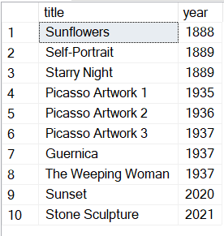

3. Find the names of all artists who have artworks in the 'Painting' category, and the number of

artworks they have in this category.

select a.name,count(aw.artistid) as a_count

from artists a

join artworks aw

on aw.artistid = a.artistid

join categories c

on c.categoryid = aw.categoryid

where c.name = 'painting'

group by a.name

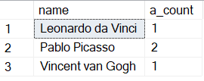

--4

4. List the names of artworks from the 'Modern Art Masterpieces' exhibition, along with their

artists and categories.

select aw.title,a.name,c.name

from artworks aw

join artists a

on a.artistid = aw.artistid

join categories c

on c.categoryid = aw.categoryid

join exhibitionartworks ea

on ea.artworkid = aw.artworkid

join exhibitions e

on e.exhibitionid = ea.exhibitionid

where e.title = 'Modern Art Masterpieces'

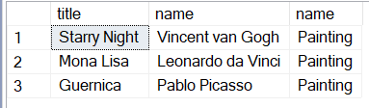

5. Find the artists who have more than two artworks in the gallery.

select a.name,count(aw.artworkid) as aw_count

from artists a

join artworks aw

on aw.artistid = a.artistid

group by a.name

having count(aw.artistid) > 2

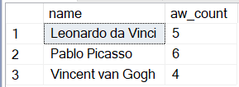

6. Find the titles of artworks that were exhibited in both 'Modern Art Masterpieces' and

'Renaissance Art' exhibitions

select aw.title

from artworks aw

join exhibitionartworks ea

on ea.artworkid = aw.artworkid

join exhibitions e

on ea.exhibitionid = e.exhibitionid

where e.title in ('Modern Art Masterpieces' ,

'Renaissance Art')

group by aw.title

having count(distinct e.title) = 2



7. Find the total number of artworks in each category

select c.name,count(aw.artworkid) as aw_count

from artworks aw

join categories c

on aw.categoryid = c.categoryid

group by c.name

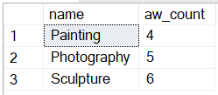

8. List artists who have more than 3 artworks in the gallery.

select a.name,count(aw.artworkid) as aw_count

from artists a

join artworks aw

on aw.artistid = a.artistid

group by a.name

having count(aw.artworkid) > 3

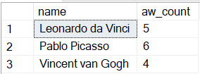

9. Find the artworks created by artists from a specific nationality (e.g., Spanish).

select aw.title

from artworks aw

join artists a

on a.artistid = aw.artistid

where a.nationality = 'spanish'

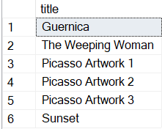

10. List exhibitions that feature artwork by both Vincent van Gogh and Leonardo da Vinci.

select e.title

from exhibitions e

join exhibitionartworks ea

on ea.exhibitionid = e.exhibitionid

join artworks aw

on aw.artworkid = ea.artworkid

join artists a

on aw.artistid = a.artistid

where a.name in ('Vincent van Gogh' ,'Leonardo da Vinci')

group by e.title

having count(distinct a.name) = 2

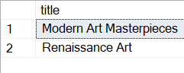

11. Find all the artworks that have not been included in any exhibition.

select aw.title

from artworks aw

left join exhibitionartworks ea

on aw.artworkid = ea.artworkid

where ea.artworkid is null

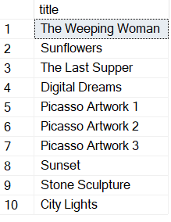

12. List artists who have created artworks in all available categories.

select a.name

from artists a

join artworks aw

on a.artistid = aw.artistid

group by a.name

having count(distinct aw.categoryid) = (select count(*) from categories) 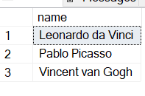

13. List the total number of artworks in each category.

select count(aw.artworkid)

from artworks aw

right join categories c

on c.categoryid = aw.categoryid

group by c.name

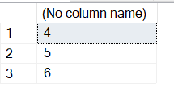

14. Find the artists who have more than 2 artworks in the gallery.

select a.name,count(aw.artworkid) as aw_count

from artists a

join artworks aw

on aw.artistid = a.artistid

group by a.name

having count(aw.artistid) > 2

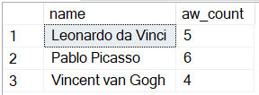

15. List the categories with the average year of artworks they contain, only for categories with more

than 1 artwork.

select c.name,avg(aw.year) as avg_year

from categories c

join artworks aw

on aw.categoryid = c.categoryid

group by c.name

having count(aw.artworkid) > 1

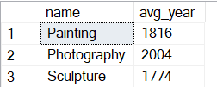

16. Find the artworks that were exhibited in the 'Modern Art Masterpieces' exhibition.

select aw.title

from artworks aw

join exhibitionartworks ea

on ea.artworkid = aw.artworkid

join exhibitions e

on e.exhibitionid = ea.exhibitionid

where e.title = 'Modern Art Masterpieces'

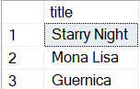

17. Find the categories where the average year of artworks is greater than the average year of all

artworks.

select c.name

from categories c

join artworks aw

on c.categoryid = aw.categoryid

group by c.name

having avg(aw.year) > (select avg(year) from artworks)



18. List the artworks that were not exhibited in any exhibition.

select aw.title

from artworks aw

left join exhibitionartworks ea

on aw.artworkid = ea.artworkid

where ea.artworkid is null

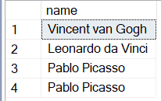

19. Show artists artists who have artworks in the same category as "Mona Lisa."

select a.name

from artists a

join artworks aw

on aw.artistid = a.artistid

where aw.categoryid = (select categoryid from artworks

where title = 'Mona Lisa')

20. List the names of artists and the number of artworks they have in the gallery.

select a.name,count(aw.artworkid) as aw_count

from artists a

join artworks aw

on aw.artistid = a.artistid

group by a.name

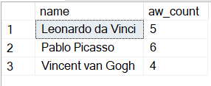

INSERT INTO artists (artistid, name, biography, nationality) VALUES

(4, 'Claude Monet', 'Founder of French Impressionist painting.', 'French'),

(5, 'Frida Kahlo', 'Mexican painter known for self-portraits.', 'Mexican');

insert into artworks (artworkid, title, artistid, categoryid, year, description, imageURL) values

(4, 'The Weeping Woman', 1, 2, 1937, 'Another powerful painting by Picasso.', 'weeping_woman.jpg'),

(5, 'Sunflowers', 2, 2, 1888, 'A series of still-life paintings by Van Gogh.', 'sunflowers.jpg'),

(6, 'The Last Supper', 3, 2, 1495, 'A mural painting by Leonardo da Vinci.', 'last_supper.jpg'),

(7, 'Self-Portrait', 1, 3, 1889, 'Vincent van Gogh’s self-portrait.', 'self_portrait.jpg'),

(8, 'Warrior Statue', 2, 3, 1504, 'A powerful sculpture by Leonardo da Vinci.', 'warrior_statue.jpg');

insert into categories (categoryid, name) values

(4, 'Digital Art'),

(5, 'Surrealism');

delete from categories

where categoryid = 5

insert into artworks (artworkid, title, artistid, categoryid, year, description, imageURL) values

(9, 'Digital Dreams',3 , 3, 2021, 'A modern digital artwork by Picasso.', 'digital_dreams.jpg');

INSERT INTO artworks (artworkid, title, artistid, categoryid, year, description, imageURL) VALUES

(10, 'Picasso Artwork 1', 1, 3, 1935, 'Another Picasso painting.', 'picasso1.jpg'),

(11, 'Picasso Artwork 2', 2, 3, 1936, 'A Picasso sculpture.', 'picasso2.jpg'),

(12, 'Picasso Artwork 3', 3, 3, 1937, 'A Picasso photograph.', 'picasso3.jpg');

select* from categories

insert into exhibitionartworks (exhibitionid, artworkid) values

(2, 7),

(2, 8);

INSERT INTO artworks (artworkid, title, artistid, categoryid, year, description, imageURL) VALUES

(13, 'Sunset', 1, 3, 2020, 'A beautiful sunset painting.', 'sunset.jpg'),

(14, 'Stone Sculpture', 2, 3, 2021, 'A marble sculpture.', 'sculpture.jpg'),

(15, 'City Lights', 3, 3, 2022, 'A vibrant cityscape photograph.', 'city.jpg');

delete artworks

where artworkid = 15